Padding & Strides in CNN | CNN | Deep Learning

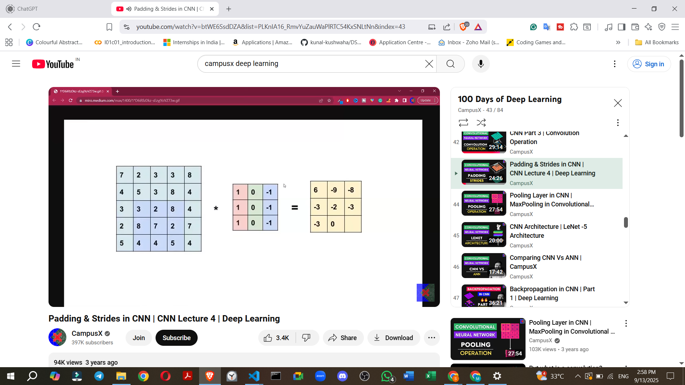

covering Padding and Strides in Convolutional Neural Networks (CNNs), drawing from the provided source:

**1. Introduction to Padding and Strides**

* This class continues the discussion on deep learning and CNNs, following a previous video on the convolution operation.
* It focuses on two additional operations crucial for CNNs: **Padding** and **Strides**.

**2. Need for Padding**

* Before discussing padding, it's essential to understand *why* it's needed.
* When a filter is convolved over an image, the resulting feature map is **smaller** than the original image.
  + For example, a 5x5 image convolved with a 3x3 filter results in a 3x3 feature map.
* **Problem 1: Reduction in Resolution/Information Loss**
  + If multiple convolutional layers are applied consecutively, the image size will continuously decrease.
  + This leads to a loss of information with each layer, which is generally undesirable.
* **Problem 2: Underrepresentation of Border Pixels**
  + Pixels at the borders (sides, top, bottom) of an image are part of fewer convolution operations compared to the central pixels.
  + For instance, a pixel in the top row might participate in only one convolution operation, while a central pixel could be part of three to four operations.
  + This means that when the feature map is generated, the central pixels have a greater "say" or importance, while the side pixels' influence is reduced.
  + If crucial information is located at the borders, it might not be effectively filtered out and represented in the feature map.
* Padding solves both these problems.

**3. What is Padding?**

* Padding involves **adding rows and columns** around the border of an image.
* Typically, these added pixels have a value of **zero**, which is why it's often referred to as **zero-padding** in literature.
* **How it works (Example):**

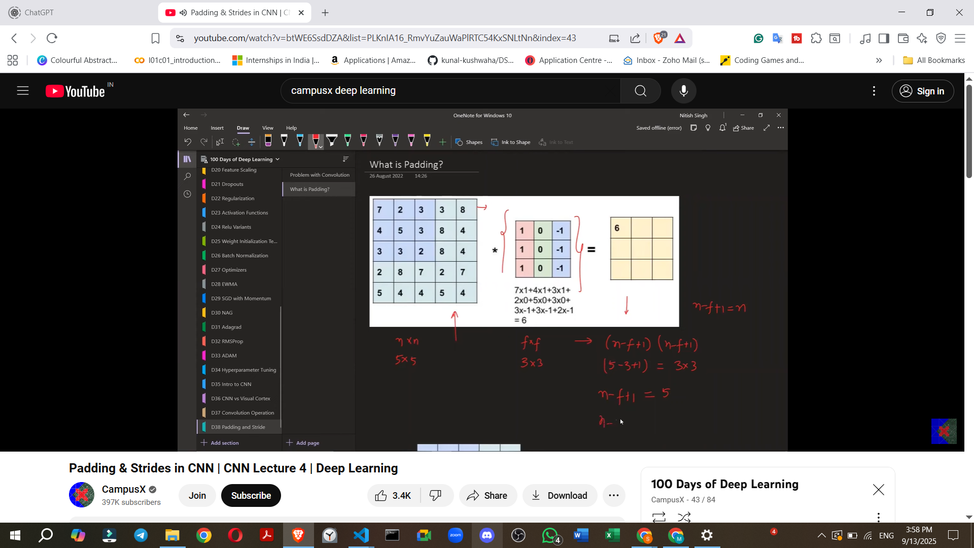

* + If you have a 5x5 image and add one column and one row on each side (top, bottom, left, right), the image becomes 7x7.
  + When a 3x3 filter is then convolved over this 7x7 padded image, the resulting feature map is 5x5, the **same size** as the original input image.

**4. Formula for Feature Map Size with Padding**

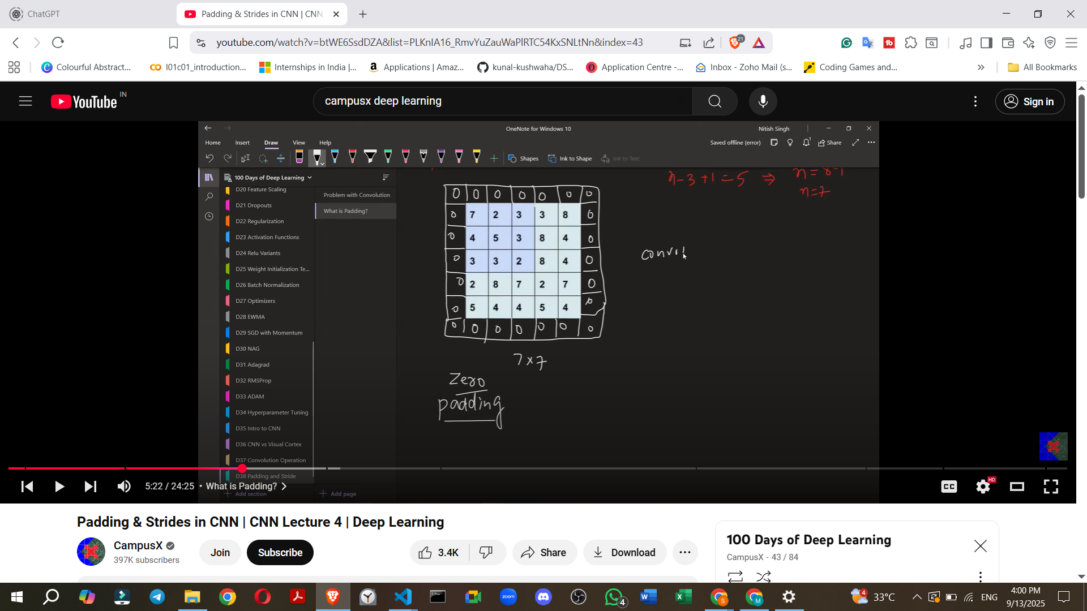

* **Without Padding:** For an N x N image and an F x F filter, the feature map size is **(N - F + 1) x (N - F + 1)**.
* **With Padding:** If 'P' represents the amount of padding (e.g., P=1 for adding one pixel on each side), the formula becomes **(N + 2P - F + 1) x (N + 2P - F + 1)**.

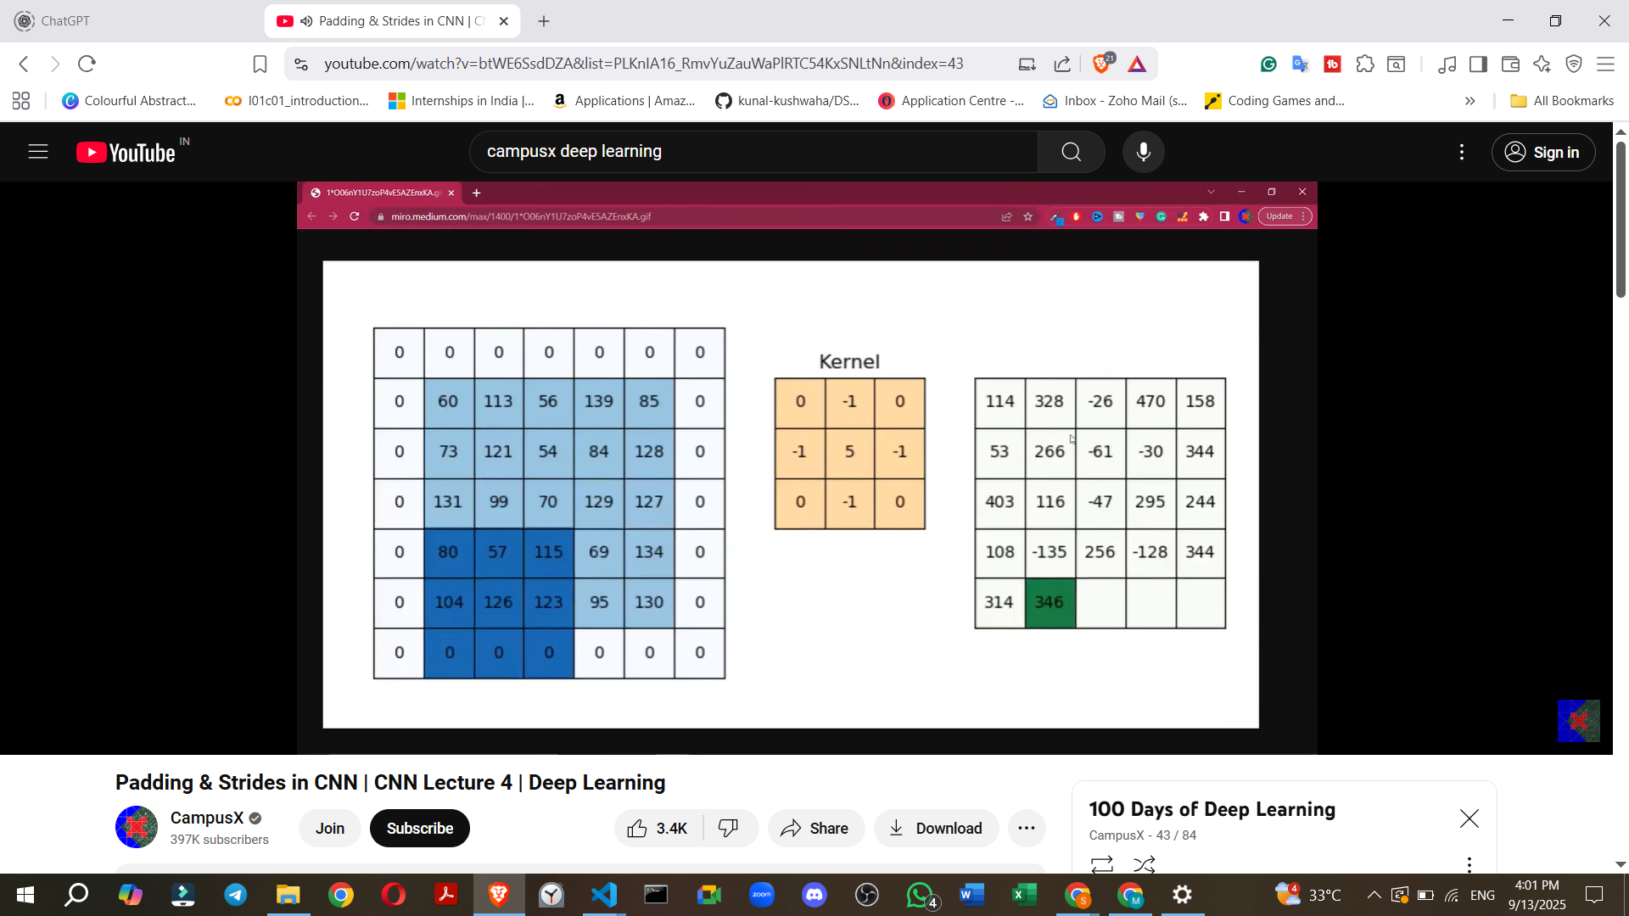

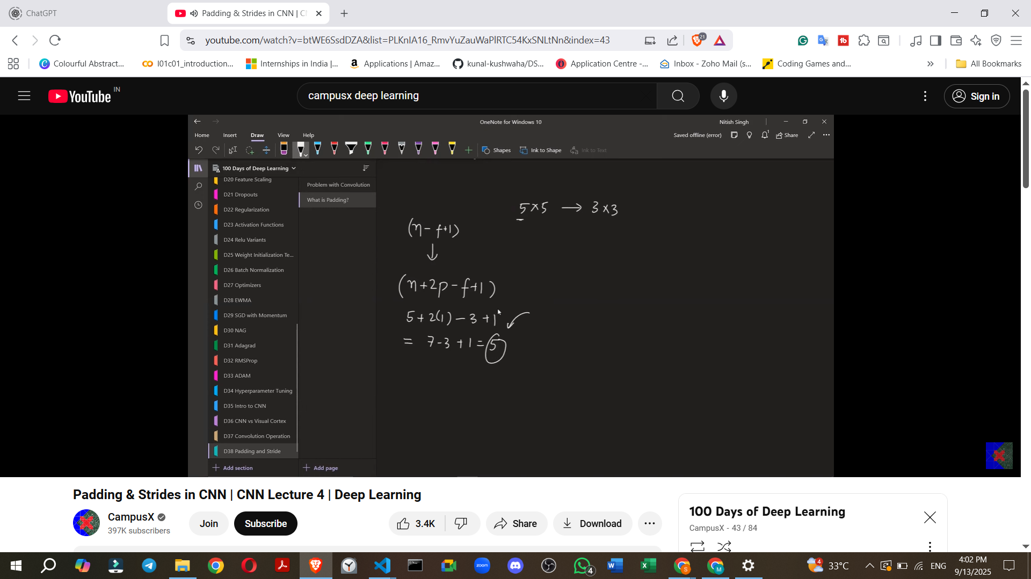

* + **Example:** For a 5x5 image (N=5) with P=1 padding and a 3x3 filter (F=3): (5 + 2*1 - 3 + 1) = (5 + 2 - 3 + 1) = 5. So, the output is a 5x5 feature map.

**5. Padding Options in Keras**

* Keras offers two primary padding options:

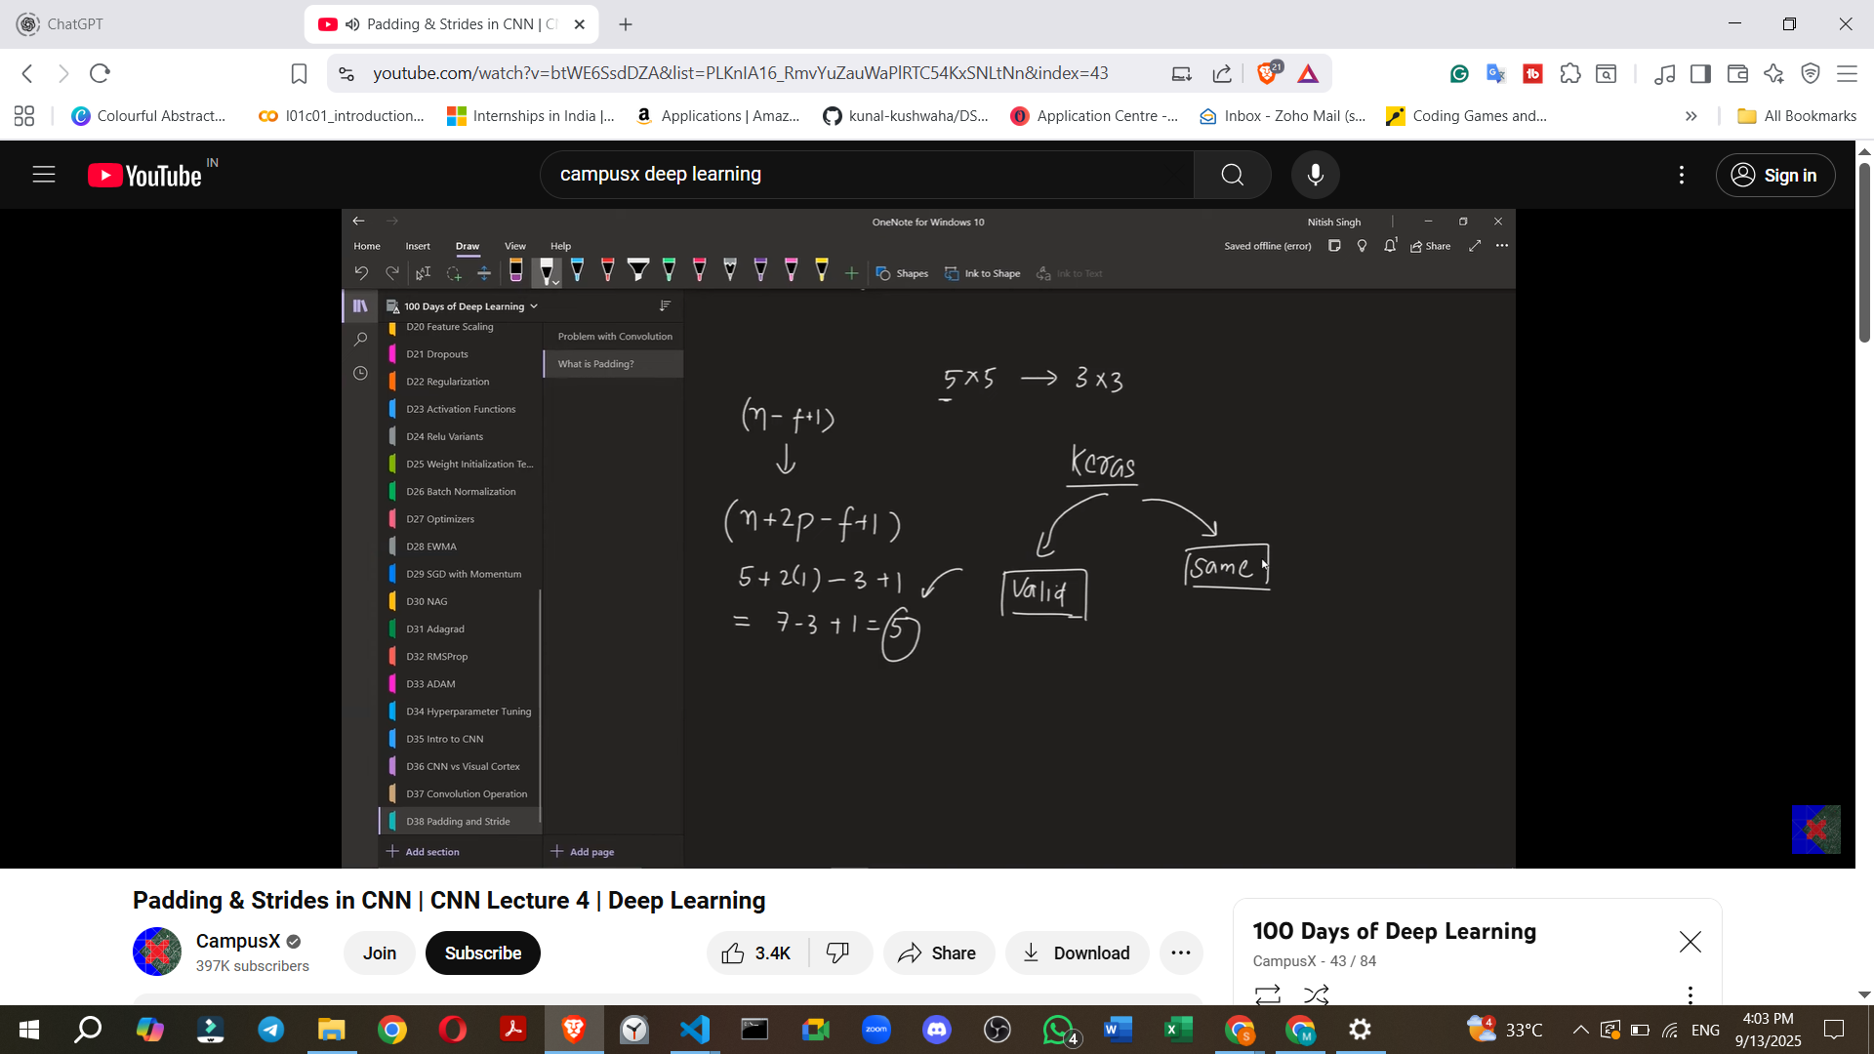

* + **'valid'**: No padding is applied. Convolution happens normally, and the output feature map will be smaller than the input.
  + **'same'**: Keras automatically calculates and applies the necessary amount of padding to ensure that the **output feature map has the same size as the input image**.
* **Keras Demo for Padding:**

[**keras-padding-demo.ipynb**](https://colab.research.google.com/drive/1HBMLctcBnhvV6Rj62Zc8eAXERQw54l2H?usp=sharing)

* + A model without padding (padding='valid') shows an input of 28x28 progressively reducing to 26x26, then 24x24, and finally 22x22 after three convolutional layers. This follows the (N - F + 1) formula.
  + The exact same model, but with padding='same', maintains the image size at 28x28 across all convolutional layers. This demonstrates how 'same' padding prevents information loss by preserving resolution.

**6. What are Strides?**



* The stride value defines **how many pixels the filter shifts** (or "steps") across the input image after each convolution operation.
* **Default Stride (Stride = 1):** In a standard convolution, the filter moves one pixel to the right, and once it reaches the end of a row, it moves one pixel down. This is a stride of 1x1.

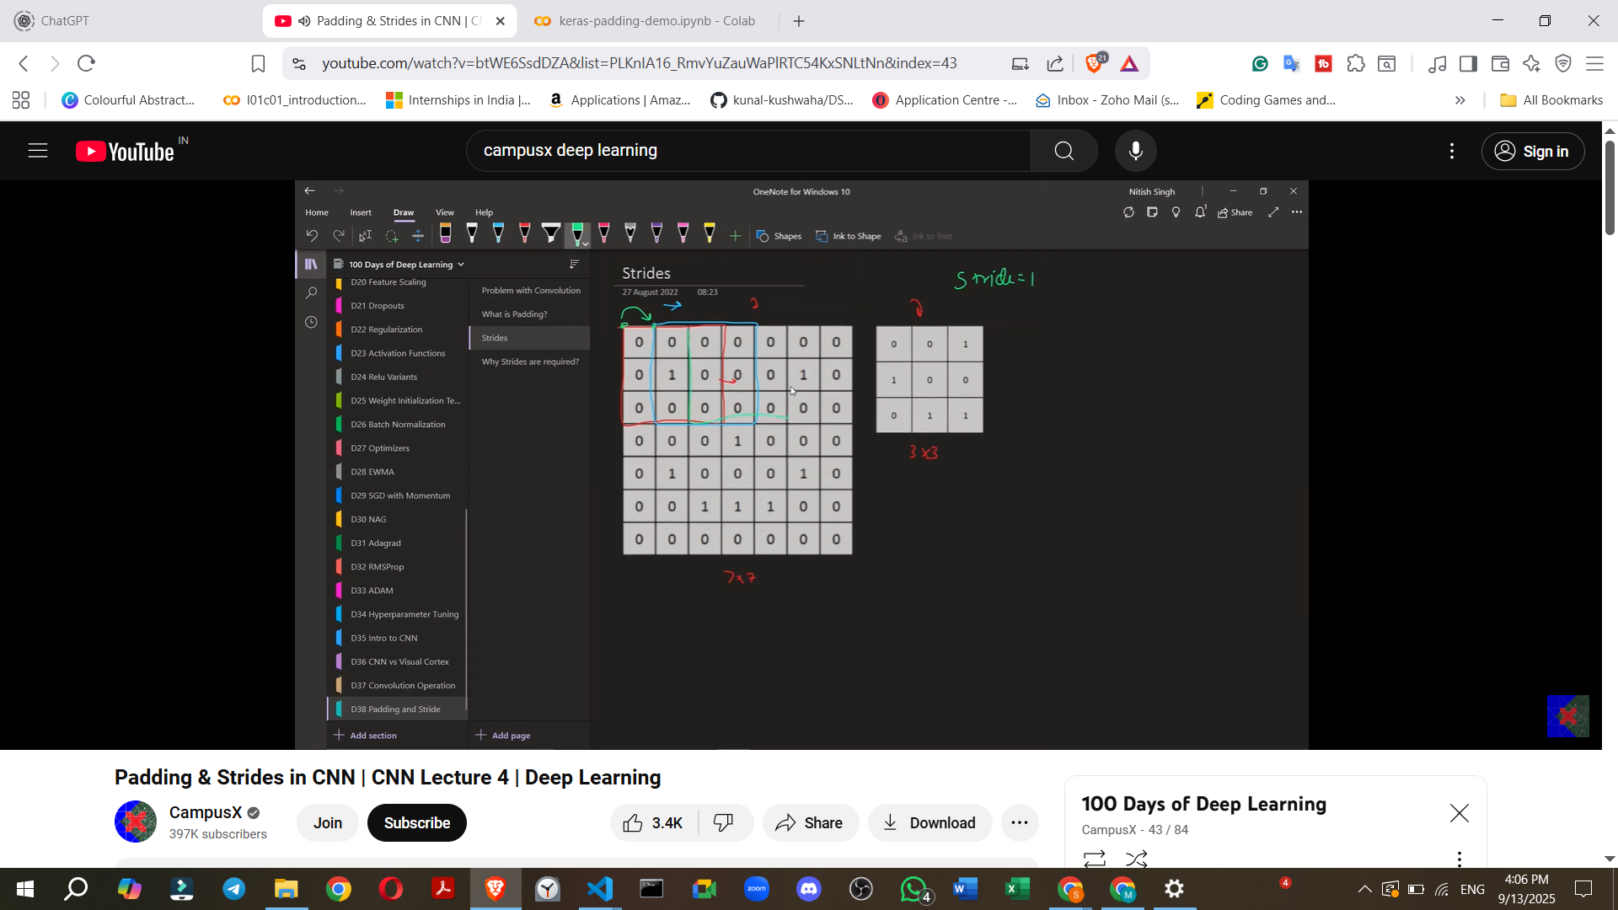

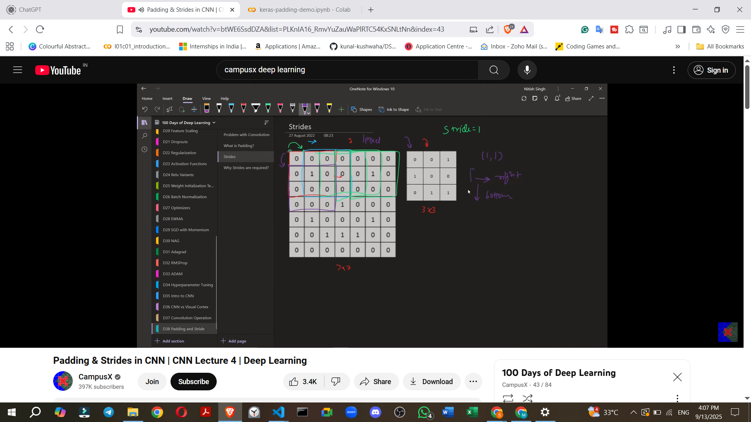

* **Custom Strides (e.g., Stride = 2):**
  + If the stride is set to 2, the filter will move **two pixels** to the right after each operation.
  + When moving down to the next row, it will also jump **two pixels** down.
  + This "skipping" of pixels means the filter covers less of the image and takes larger steps.

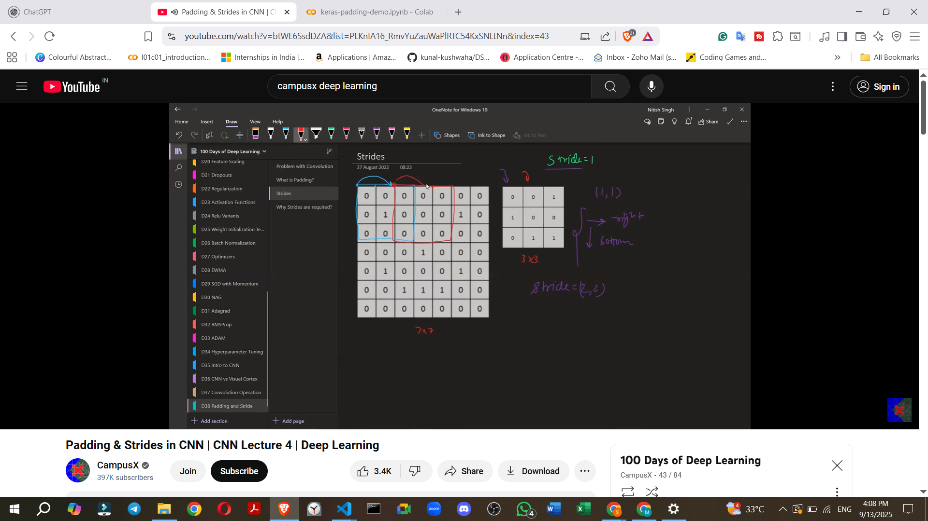

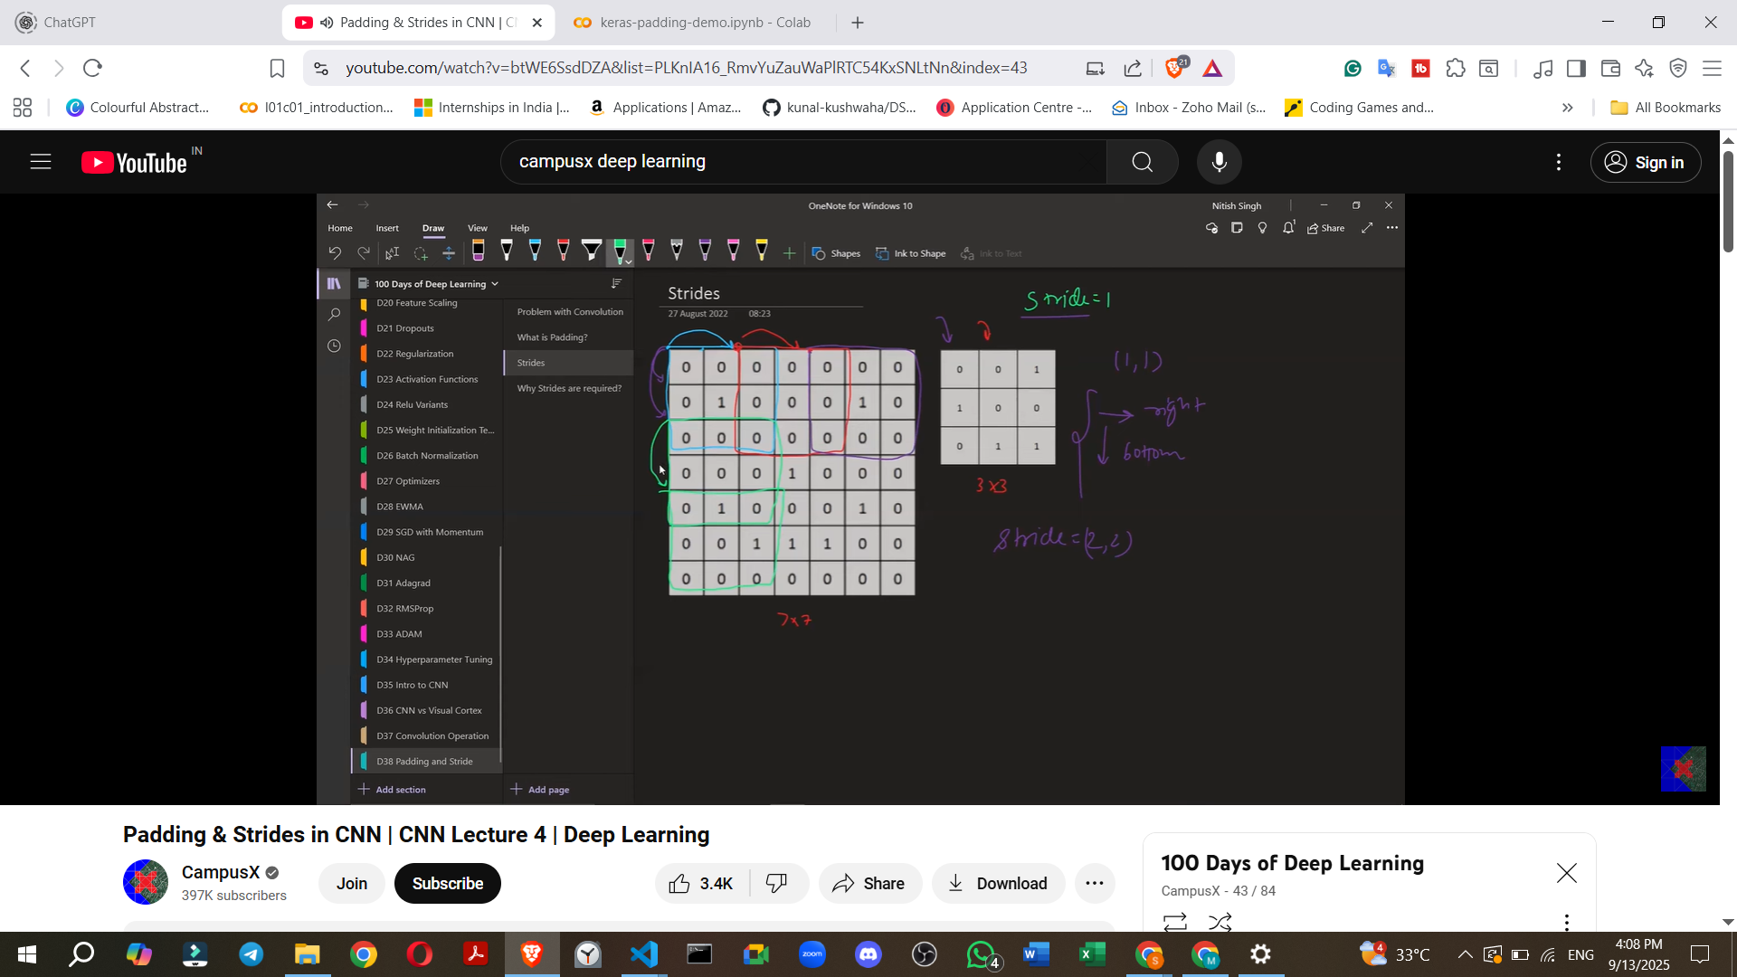

**7. Effect of Strides on Feature Map Size**

* Increasing the stride value **decreases the size of the feature map**.
* **Formula for Feature Map Size with Strides (without Padding):**
  + For an N x N image, an F x F filter, and a stride 'S', the feature map size is **((N - F) / S + 1) x ((N - F) / S + 1)**.

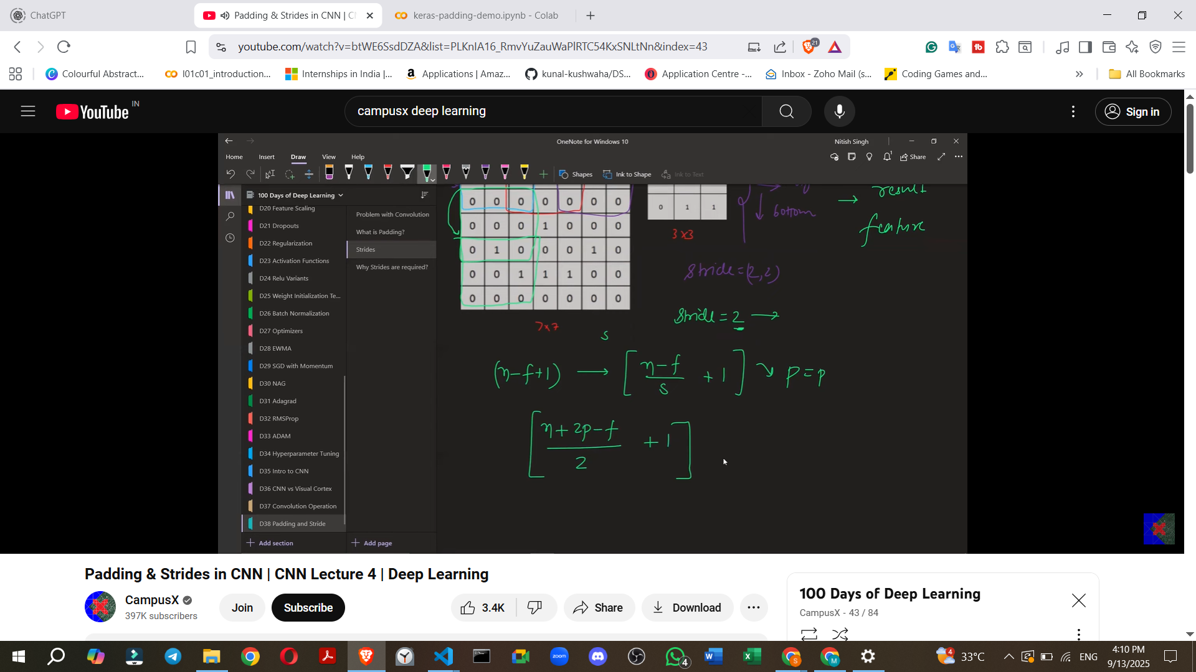

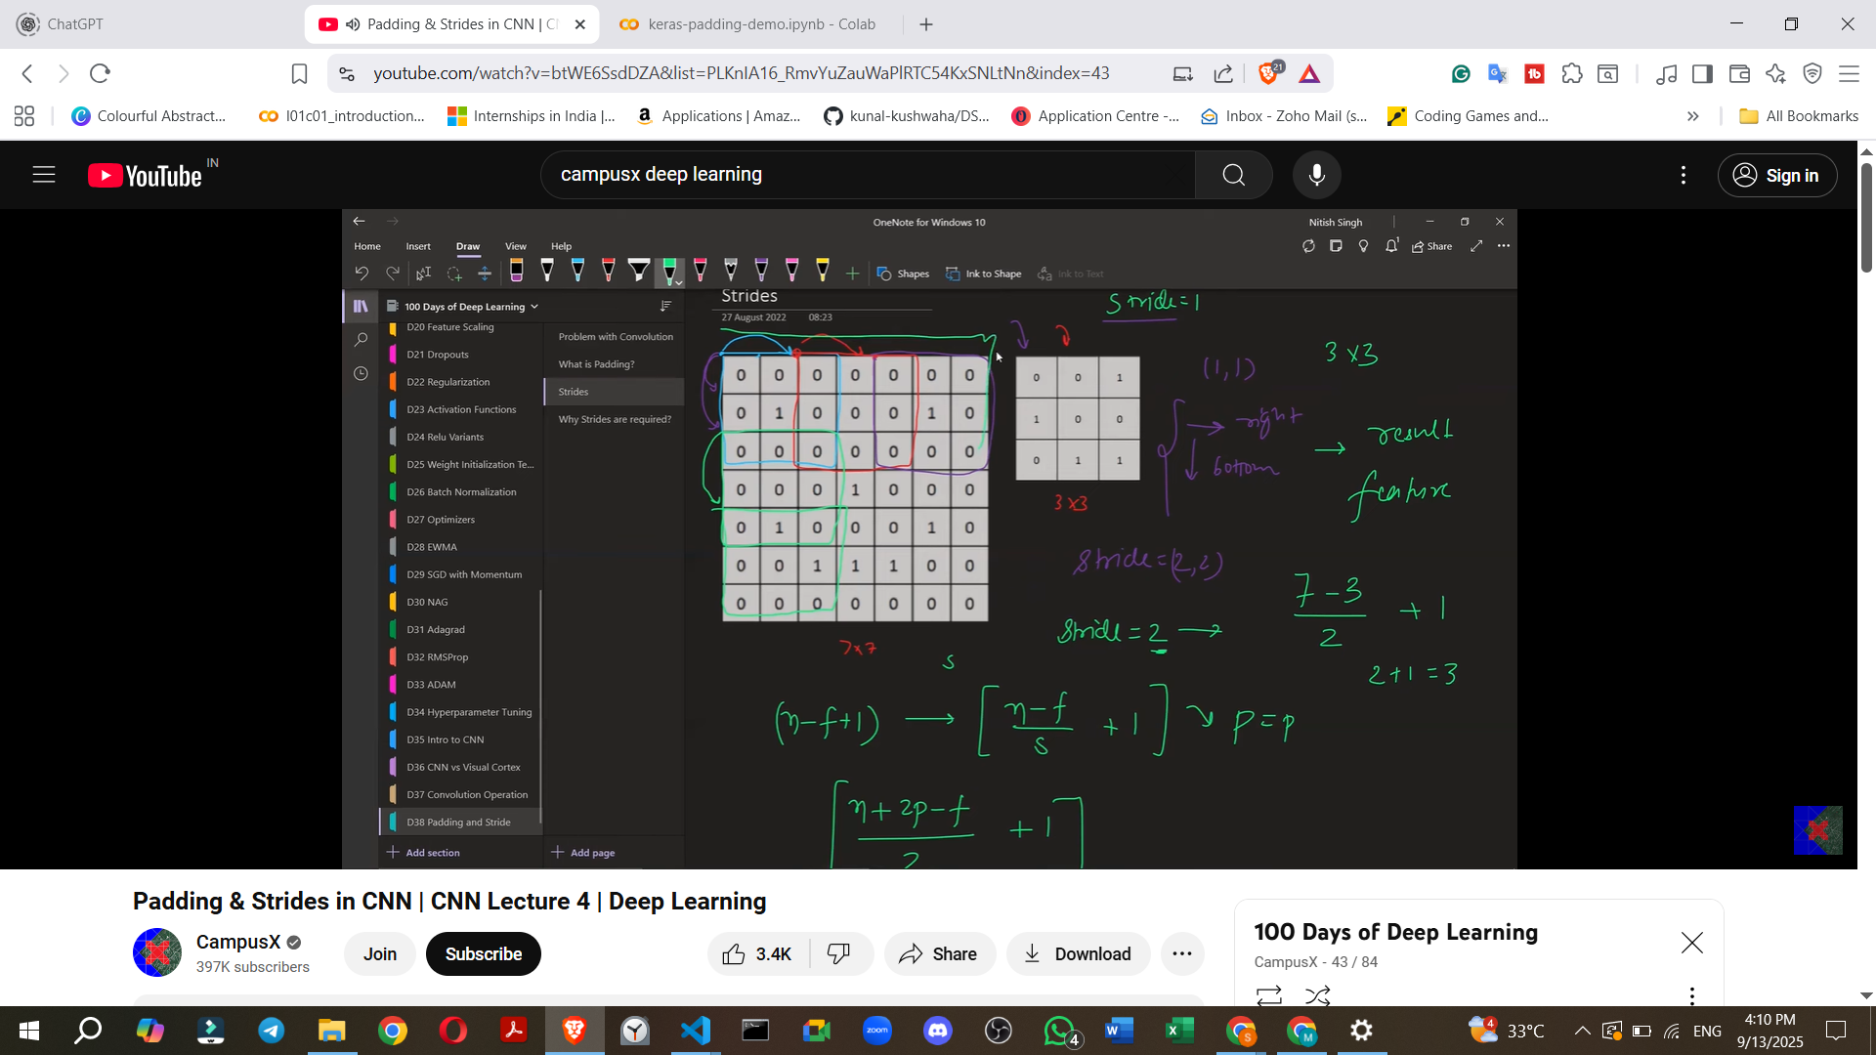

* **Formula for Feature Map Size with Strides and Padding:**
  + If padding 'P' is also considered, the formula becomes **((N + 2P - F) / S + 1) x ((N + 2P - F) / S + 1)**.
  + **Example:** For a 7x7 image (N=7), a 3x3 filter (F=3), and a stride of 2 (S=2) with no padding (P=0): ((7 + 2*0 - 3) / 2 + 1) = (4 / 2 + 1) = (2 + 1) = 3. The output feature map would be 3x3.
  + If P=1 padding was applied: ((7 + 2*1 - 3) / 2 + 1) = (6 / 2 + 1) = (3 + 1) = 4. The output feature map would be 4x4.
  + 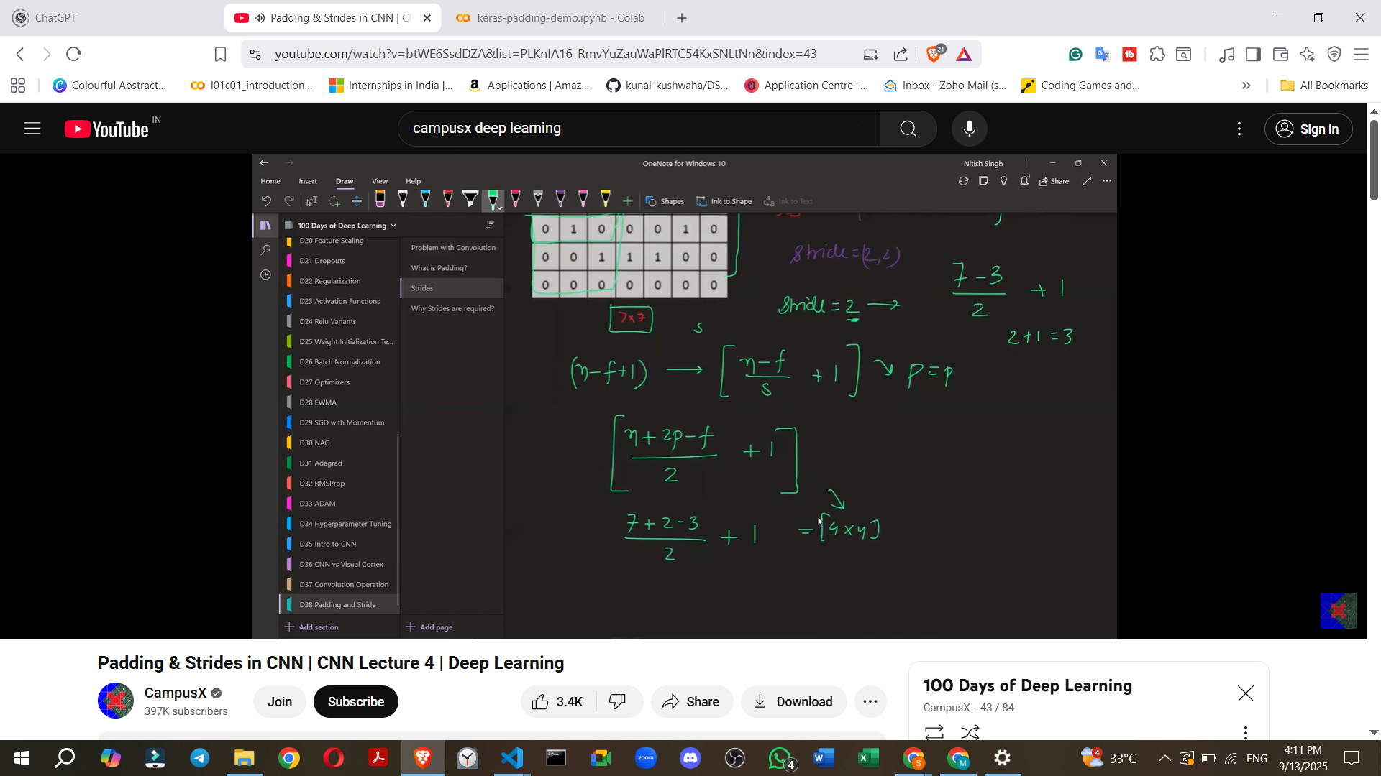

**8. Special Case: Decimal Values with Strides**

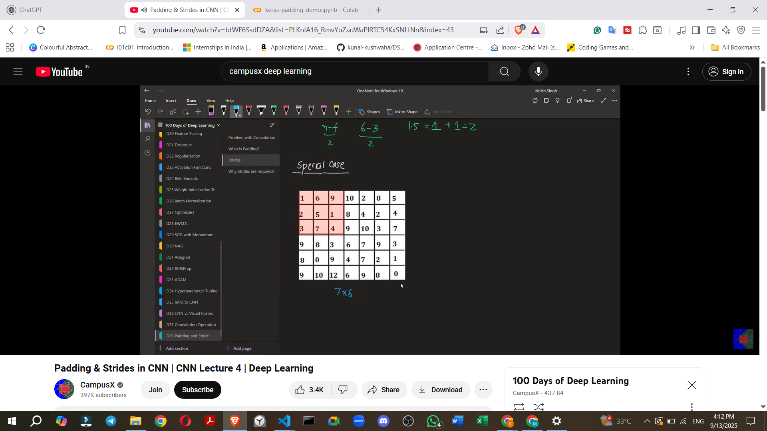

* When calculating the feature map size using the stride formula, if (N - F) / S (or (N + 2P - F) / S) results in a **decimal value**, a **floor operation** is applied.
* This means the result is rounded **down** to the nearest whole number.
* **Reason:** A decimal value indicates that there are not enough pixels remaining for the filter to perform a full convolution operation with the given stride, so that last incomplete operation is simply not performed.

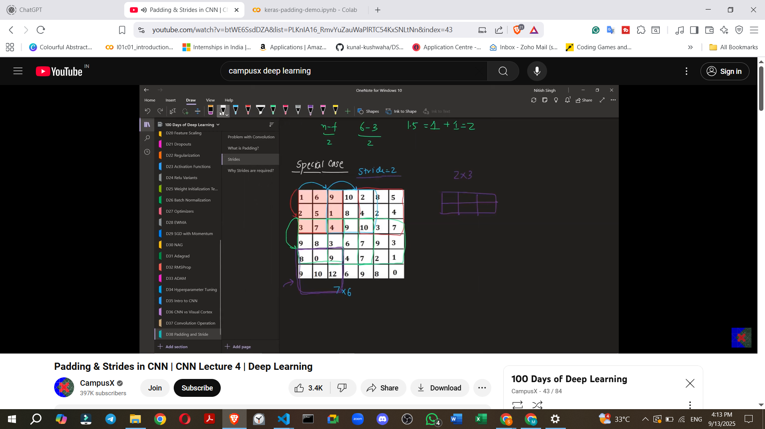

* **Example:** For a 6x7 image (N_rows=6, N_cols=7), a 3x3 filter (F=3), and a stride of 2 (S=2):
  + **For Rows:** (6 - 3) / 2 + 1 = 3 / 2 + 1 = 1.5 + 1 = 2.5. Applying floor: 1 + 1 = **2** rows.

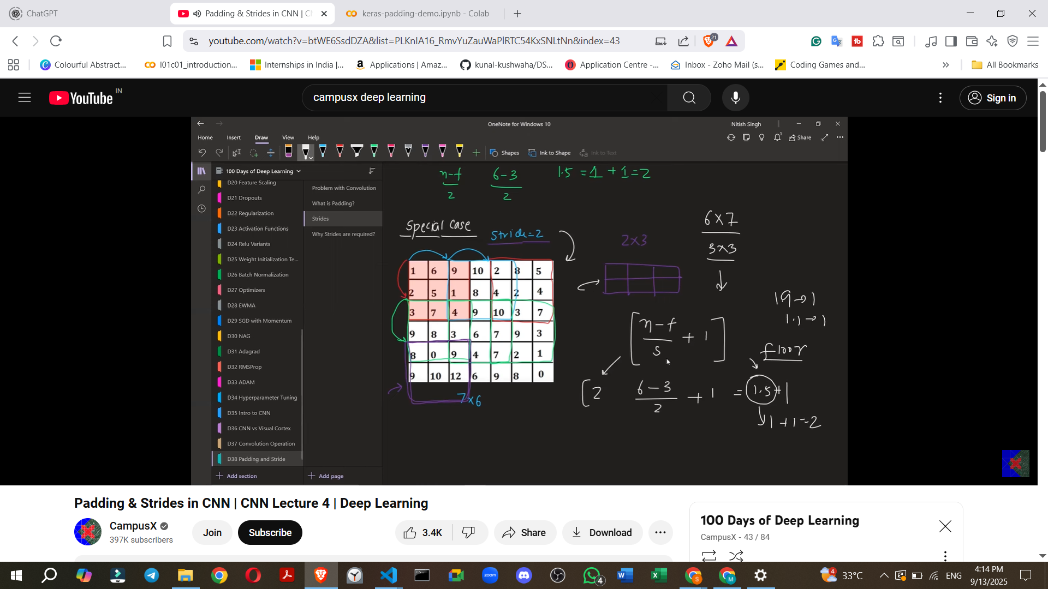

* + **For Columns:** (7 - 3) / 2 + 1 = 4 / 2 + 1 = 2 + 1 = **3** columns.

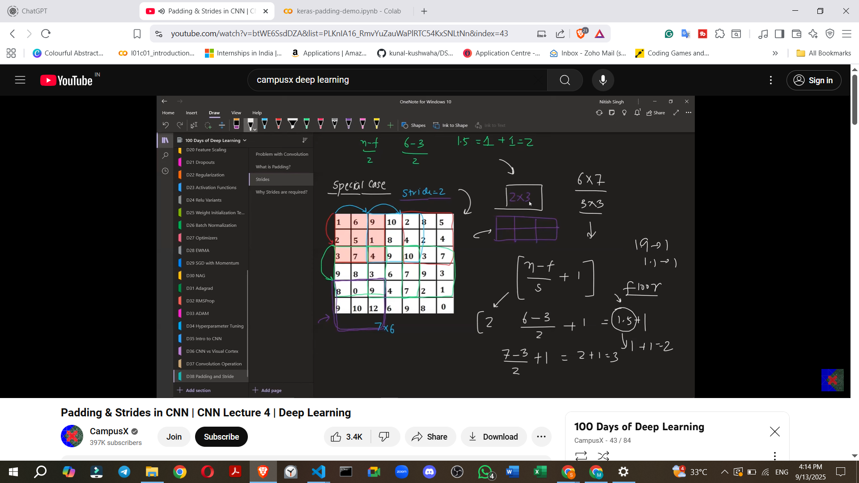

* + The resulting feature map would be 2x3.

**9. Need for Strides (Why use Stride > 1?)**

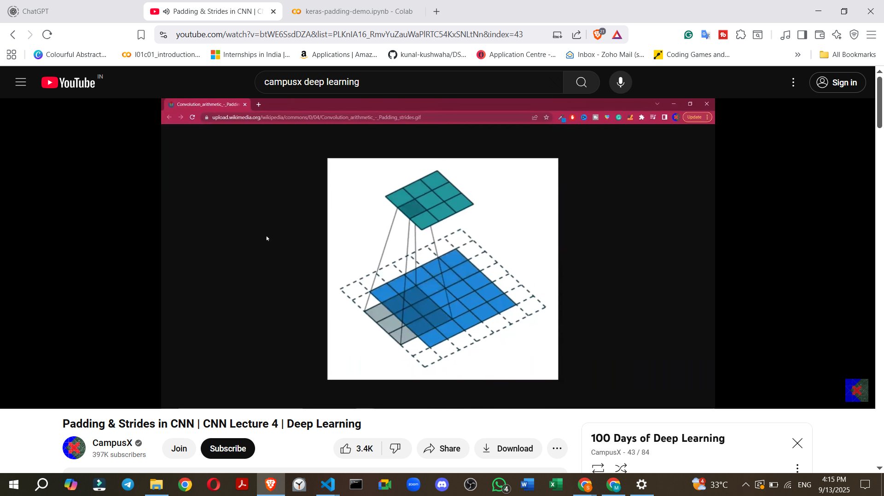

* Using a stride greater than one is sometimes called "strided convolution".
* There are two primary reasons for using strided convolution:
  + **1. Focusing on High-Level Features:**
    - A small stride (e.g., 1) captures fine details or "low-level features" in an image.
    - A larger stride causes the CNN to "jump through" information, essentially skipping many pixels.
    - This results in the CNN capturing only "high-level" or "coarse" features, which might be sufficient or desired for certain computer vision problems.
  + **2. Reducing Computational Power/Speeding up Training:**
    - A larger stride means fewer convolution operations are performed.
    - This can significantly speed up the training process, especially for very large datasets.
    - **Note:** This reason has become less critical in recent years due to increased computing power, so many models now often use a default stride of 1. However, strides are still relevant for specific problems.

**10. Implementing Strides in Keras**

[**keras-padding-demo.ipynb**](https://colab.research.google.com/drive/1HBMLctcBnhvV6Rj62Zc8eAXERQw54l2H?usp=sharing)

[**keras-padding-demo.ipynb**](https://colab.research.google.com/drive/1HBMLctcBnhvV6Rj62Zc8eAXERQw54l2H?usp=sharing)

* In Keras, strides are implemented using the strides parameter in the Conv2D layer.
* The strides parameter takes a **tuple** (e.g., (2, 2)) where the first value is the stride for horizontal movement and the second for vertical movement.
  + For example, strides=(2, 2) means the filter moves 2 pixels horizontally and 2 pixels vertically.
  + It's possible to use different stride values for horizontal and vertical directions (e.g., strides=(2, 1)).
* **Keras Demo for Strides:**
  + A model with an input of 28x28 and three convolutional layers, each with strides=(2, 2) (and implicitly padding='valid' since it's not specified as 'same'), shows a rapid reduction in image size.
  + After the first layer, the image reduces to 13x13 (calculated as (28 - 3) / 2 + 1 = 12.5 + 1 = 13.5, floored to 13).
  + It then reduces to 7x7 and further to 4x4 after subsequent layers, demonstrating significant information loss (reduction in resolution).

**11. Future Topics**

* The next video will cover **Pooling operations**.
* Following that, a complete CNN architecture will be built.